

**CIVIL, ENVIRONMENTAL & GEOMATIC ENGINEERING**

**COURSEWORK COVER SHEET**

|  |  |
| --- | --- |
| **Group No:**  3  **Coursework Title:**  Design Project: A New Two-Storey School    **Name of Staff Member Responsible for Marking:**  Prof. Chanakya Arya    **Submission Deadline:**  30/10/2024 | **Name of Personal Tutor (for return of coursework after marking):**  N/A        **Date of laboratory (if applicable):**  N/A      **Programme:** Engineering (Civil)  **Year:** 3 |

|  |  |
| --- | --- |
| **Student Name:** Nelson Cosme,Fifi Chan, Matthew Chu, Feiyao Chen, Ming Hoong Ch’ng, Rachel Chang, Bochuan Chang    **Student UCL ID Number:**  22085338, 22093177, 22007940, 22035937, 22169305, 22019528    **Date of submission:** _______30/10/2024______ | |
|  | |

*If you have any questions, please consult the department’s Guidance Notes for Coursework.

**MARKER’S COMMENTS:**

Table of Contents

Introduction and Project Overview 3

Project Background and Design Data 3

Design statement and objectives 3

Project goals and key design requirements 3

Standards and Codes 4

Carbon Calculation 4

Cost Calculation 4

Construction timeline 4

Structural analysis framework 4

Assumptions for structural analysis 4

Loading considerations 4

Structural analysis 5

Materials Selection 5

Materials Used in Design 5

General arrangement 6

Overview of layout and structure 6

Floor and Beam Design 11

First-floor slab design 11

Beam design: 18

Beam C1/2 19

Beam C2/3 26

Beams C2-D2 31

Beam C3-D3 33

Column design 38

Ground floor column C2 DESIGN CALCULATION 38

Base Plate and Connections 47

Base Plate Design 47

Column to Base Connection Design for lapping of reinforcement 47

Foundation Design 47

Foundation Structure and Calculations 47

Cost Analysis 50

Project Cost Assessment for materials 50

Carbon Footprint Analysis 51

Environmental Impact Assessment 51

Construction Timeline 52

Conclusion 54

Summary of Key Findings 54

Appendix 54

# Introduction and Project Overview

## Project Background and Design Data

This report presents the structural frame design for a new two-storey school building. The design incorporates cavity brickwork for the gable walls along gridlines A and F and fully glazed façades on gridlines 1 and 3 to meet the architect's vision. Non-loadbearing wall panels will be used between the main structural elements, with a dedicated stairwell positioned between gridlines C and D, providing vertical circulation. The project requires a reinforced concrete frame that achieves both structural stability and the desired architectural aesthetic, supporting the building’s functional requirements in a school setting​.

# Design statement and objectives

## Project goals and key design requirements

The goal of this project is to design the structural frame of a new two-storey building along with the given requirements by the architect, including where gables A and F are cavity brickwork, gridlines 1 and 3 to be fully glazed on the external façade and the non-loading bearings between the wall panels. Design calculations and detail drawings are needed to be provided following the European Standards having the frame to be built with reinforced concrete. The general arrangement of the first floor is created while ensuring overall lateral stability with design calculations of specific members with the specific load combinations requested by the clients. The construction cost and time will be analysed along with the carbon footprint to provide the most efficient, sustainable and economical design.

Table 1: Key Details of slab

|  |  |  |  |  |  |  |
| --- | --- | --- | --- | --- | --- | --- |
| Type of slab | Structure Class | Exposure class | Concrete grade | End support | Shear connectors and spacing | Mesh |
| Two ways  slab | S3 | XC1 | C25/C30 | Fixed | Not required, see hand calc. for detail | Depends, please see Appendix and hand calculation |

Table 2: Key Dimensions of Beams

|  |  |  |  |  |  |
| --- | --- | --- | --- | --- | --- |
| Beams | Beam Span (m) | Dimension (mm) | Exposure class | Self-weight (kg) | Concrete grade |
| C1/2 | 9.825 | 400 x 600 | XC1 | 58.5 | C25/30 |
| C2/3 | 7.7 | 400 x 600 | XC1 | 45.8 | C25/30 |
| C2-D2 | 5 | 280 x 350 | XC1 | 14.0 | C25/30 |
| C3-D3 | 5 | 280 x 350 | XC1 | 14.0 | C25/30 |

Table 3: Key Dimensions of Column

|  |  |  |  |  |  |
| --- | --- | --- | --- | --- | --- |
| Column  Number | Length (m) | Column Dimension (mm) | Padding Dimension (mm) | Flange Classification | Concrete Grade for column |
| C2 | 3.5 | 400 x 400 | 650 x 650 | S3 | C30/37 |

# Standards and Codes

To ensure the serviceability and safety of the design, the structural design is in accordance with the following code of practice:

* Eurocode 0: Basis of Structural Design (EN 1990)
* Eurocode 1: Actions on Structures (EN 1991)
* Eurocode 2: Design of Concrete Structures (EN 1992)
* Eurocode 7: Geotechnical Design (EN 1997)
* Eurocode 8: Design of structures for earthquake resistance (EN 1998)

## Carbon Calculation

Feiyao

## Cost Calculation

Feiyao

## Construction timeline

# Structural analysis framework

## Assumptions for structural analysis

### Loading considerations

#### Roof loading

Table 4: Permanent and Imposed Loading on Roof

|  |  |  |
| --- | --- | --- |
|  | Loading (kN/ $m^{2}$) | |
| Permanent | Imposed |
| Roof | $$6.25$$ | $$1.5$$ |

#### Floor loading

The permanent floor loading is derived from the brief specifications and the manufacturer's unit weight data. Meanwhile, the imposed floor loading is based on the guidelines provided in the National Annex to BS EN 1991-1-1:2002.

Table 5: Permanent and Imposed Loadings on Floor

|  |  |  |
| --- | --- | --- |
| Loading (kN/ $m^{2}$) | | |
| Permanent | Floor | $$1.75 kN/m^{2}$$ |
| Internal Partitions | $$3 kN/m^{2}$$ |
| External Cladding | $$1.25 kN/m^{2}$$ |
| Imposed | Classrooms | $$3 kN/m^{2}$$ |
| Corridors | $$3 kN/m^{2}$$ |
| Office | $$2.5 kN/m^{2}$$ |
| Storage | $$7 kN/m^{2}$$ |

The load calculations for the structural analysis reveal essential details regarding the dead and variable loads. The dead load from the floor finishing and ceiling services is 1.75 kN/m², while a 150 mm thick partition block wall, with a height of 3.5 m, contributes a line uniformly distributed load (UDL) of 10.5 kN/m. The cladding façade adds an area load of 1.25 kN/m², resulting in a line UDL of 4.375 kN/m. For self-weight considerations, the minimum effective depth is calculated based on a basic ratio l/d=26, yielding an effective depth of 192.31 mm. With a main steel diameter assumed at 10 mm, the overall height, including the nominal cover, is rounded to 225 mm, resulting in a new effective depth of 195 mm. The concrete self-weight is determined to be 5.625 kN/m². In terms of variable loads, the classroom (C1) load is assessed at 3 kN/m², the corridor (C3) and office (B) loads at 3 kN/m² and 2.5 kN/m², respectively, and storage (E1) at 7 kN/m². The total area considered for these loadings is 49.125 m².

#### Loading layout overview

### Structural analysis

#### Structural analysis of slabs

The slab design calculations are conducted in accordance with Eurocode 2 standards for concrete structures, utilizing grade C25/30 concrete to provide the necessary strength and durability for one continuous short edge. This calculation accounts for both short and long spans, with bending moments calculated at the continuous edge and mid-span. Checks have been performed to ensure maximum bending, shear, and deflection are within acceptable limits. For detail assumption, please visit hand calculation for slab calculations.

In addition, there are more assumptions the floor plan layout, for instance, we assume the kitchen for the staffs and toilets for in general is located on Ground Floor, and hence absent of the said before from the layout on first floor can be ignored.

#### Structural analysis of beams

Each beam is calculated with fixed beam supports, as it provides resistance to axial, shear and bending moments. Maximum shear and moment are considered where the moment is calculated in the middle and shear at the supports, which can support the weight of the school, and the moment and shear caused by the wind. The maximum loading is calculated where the moment in mid-span is used as it is the largest in a uniformly distributed situation, whereas the shear is calculated at the supports. Defection and crack checked for serviceability ensuring durability and preventing excessive deformation.

Table 6: Maximum Bending Moments and Shear Forces on Beams C1/2, C2/3, C2-D2, C3-D3

|  |  |  |
| --- | --- | --- |
| Beams | Maximum Bending moment $M_{Ed}$ (kNm) | Maximum Shear Force $V_{Ed}$ (kN) |
| C1/2 | 465 | 445 |
| C2/3 | 430 | 329 |
| C2-D2 | 57 | 143 |
| C3-D3 | 56 | 141 |

#### Structural analysis of columns

During the calculation for columns, the beams dimension was set to be $450mm×550mm$, and when compared to the actual dimension of the beams $400mm ×600mm$, the calculation on the self-weight of the beams would be an overestimation, and hence this is acceptable. For detail assumption, please visit column hand calculations.

#### Structural analysis of Foundation

Assuming the loading on ground floor directly sits on the soil, and no connection for the slab, and hence, the loading is not transferred into the padding.

# Materials Selection

## Materials Used in Design

The materials selected for this project are cost-effective and sustainable concrete grades, carefully chosen to meet the specific requirements of each structural component. For the composite slab and beams, C25/30 concrete with a characteristic strength of $f_{ck}$ ​=25 MPa, it provides an optimal balance of strength, durability, and budget efficiency in compliance with BS EN 1992-1-1 standards. This grade is also applied to the beams and columns due to its structural adequacy, relatively low carbon footprint, and wide availability, supporting the project’s sustainability goals. For the pad foundation, a higher-strength C30/37 concrete ($f_{ck}$ ​=35 MPa) is used to meet the increased load-bearing requirements, ensuring long-term stability at the base. This approach optimises the project’s overall performance, cost-effectiveness, and environmental impact.

Table 7: Material Properties of the Structural Members

|  |  |  |  |  |  |
| --- | --- | --- | --- | --- | --- |
| *Material Properties* | | | | | |
| Structural  Member | Concrete Grade | Fire Resistance  (min) | Cover  (mm) | Elastic Modulus  (N/mm^2) | Exposure Class |
| Columns | 25/30 | 60 | 30 | 200000 | XC1 |
| Slab | 25/30 | 60 | 25 | 200000 | XC1 |
| Beams | 25/30 | 60 | 25 | 200000 | XC1 |

# General arrangement

## Overview of layout and structure

The first-floor general arrangement drawing shown above provides a layout of structural elements, including beams, columns, and slab configurations, along with key dimensions and material specifications. The drawing is organized into a grid format, with labelled axes and span measurements to guide placement and alignment. Main beams (MB1, MB2) and secondary beams (SB1, SB2) are specified with their respective dimensions, supporting the overall slab structure while accommodating load distribution. Additionally, columns are strategically positioned to support both vertical and lateral stability. The slab thickness is set at 225 mm.

Figure 1: General Architectural Layout

Figure 2: First Floor General Arrangement

#### Load Path and Stability

#### Load path diagram

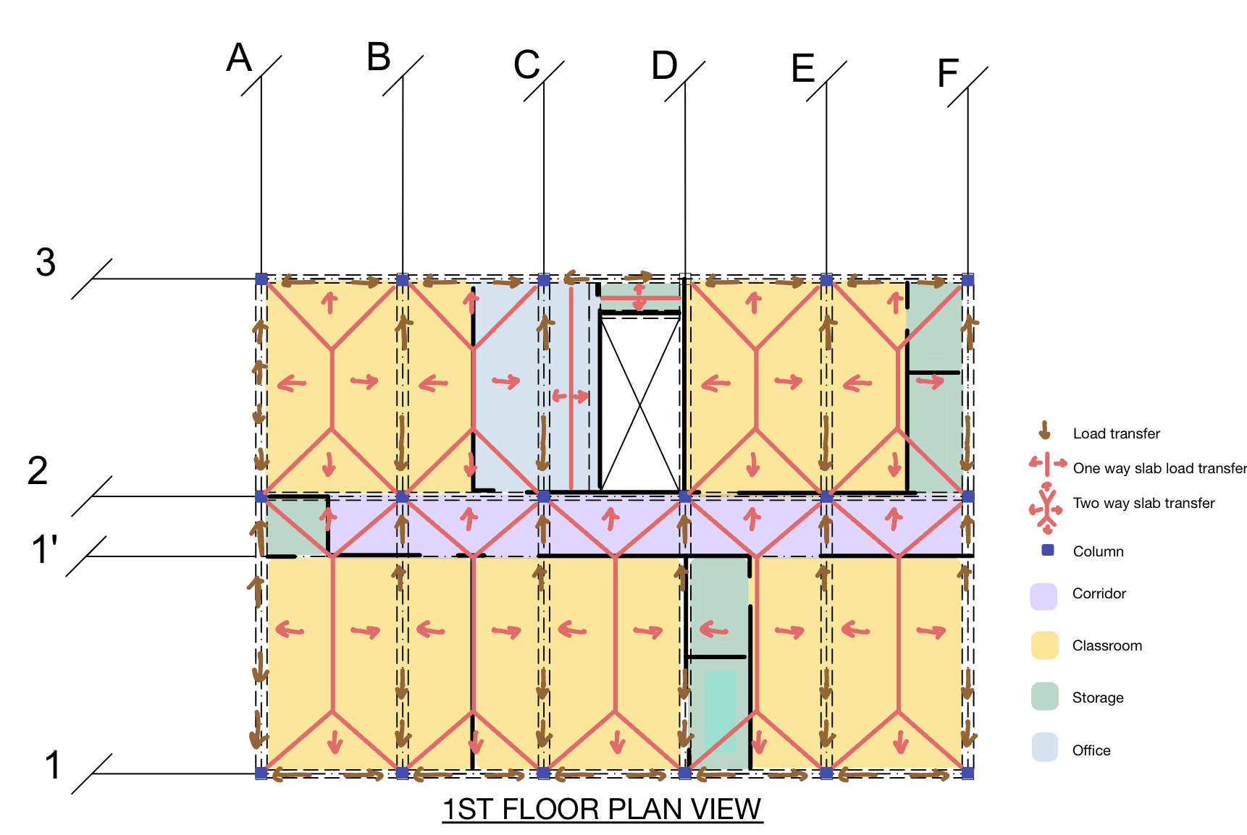

Figure 3: Load Path Diagram of First Floor Plan View

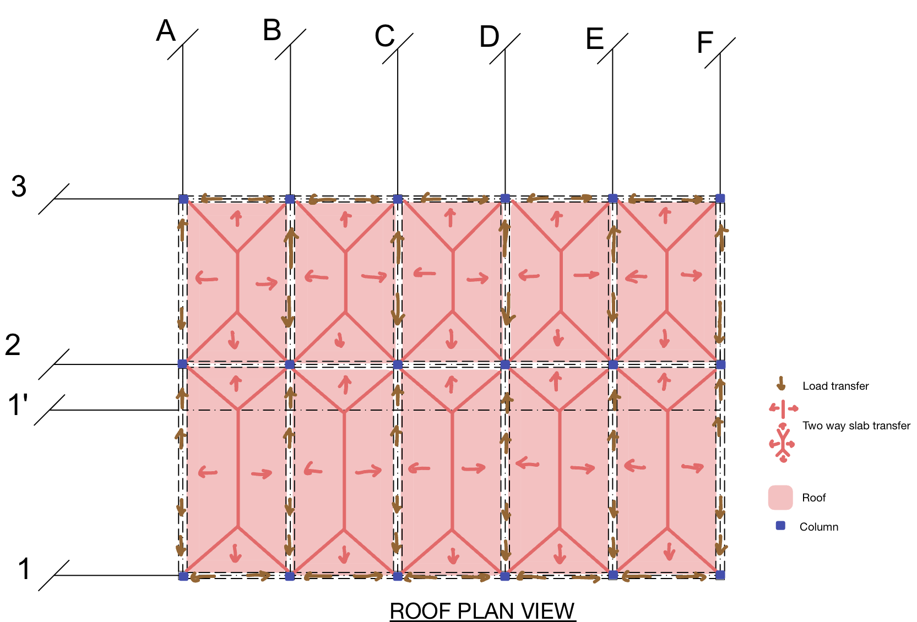

Figure 4: Load Path Diagram of Roof Floor Plan View

Figure 5: Load Path Diagram of Gridline 2 Section

The Figures above illustrate the building’s load takedown, showing load distributions and tributary areas as calculated. Due to the void in the structure, two secondary beams were added on the first floor to maintain even load distribution, as the void interrupts the uniform load path. These secondary beams aid in effectively channelling the load across the structure. No additional secondary beams were required, as the partition walls are lightweight and do not substantially impact the overall load. The load pathway follows a logical sequence: secondary beams transfer loads to the main beams, main beams pass loads to the columns, and columns ultimately transfer the load to the foundation. The presence of these secondary beams results in the slabs being classified as one-way slabs, given ly to lx ratio being less than 2.

#### Lateral stability

#### Lateral stability calculations:

##### Lateral stability system

The maximum deflection of the building is 2.5 mm, i.e. 7700/3080 of the building height which is smaller than the limit of 7700/500 of the building height. Matthew say blabla about yo

##### Lateral load path

Figure 6: Lateral Load Path

# Floor and Beam Design

## First-floor slab design

|  |  |  |  |
| --- | --- | --- | --- |
| CEGE0021  Grp | Project  School Design Project | | Job ref:--- |
| Sheet No/ 1 |
| Section: First-floor slab design | |
| Calc By.  Group 3. | Checked by: --- | Date:29/10/2024 |
|  | | | |

|  |  |  |  |  |  |  |  |  |  |  |  |  |  |  |  |  |  |  |  |
| --- | --- | --- | --- | --- | --- | --- | --- | --- | --- | --- | --- | --- | --- | --- | --- | --- | --- | --- | --- |
| CEGE0021  Grp | | | | | Project  School Design Project | | | | | | | | | | | Job ref:--- | | | |
| Sheet No/ 2 | | | |
| Section: First-floor slab design | | | | | | | | | | |
| Calc By.  Group 3. | | | | | | Checked by: --- | | | | | Date:29/10/2024 | | | |
|  | | | | | | | | | | | | | | | | | | | |
| CEGE0021  Grp | | | | | | Project  School Design Project | | | | | | | Job ref:--- | | | | | | |
| Sheet No/ 3 | | | | | | |
| Section: First-floor slab design | | | | | | |
| Calc By.  Group 3. | | | | Checked by: --- | | | Date:29/10/2024 | | | | | | |
|  | | | | | | | | | | | | | | | | | | | |
| CEGE0021  Grp | | | | Project  School Design Project | | | | | | | | | | | | | | Job ref:--- | | |
| Sheet No/ 4 | | |
| Section: First-floor slab design | | | | | | | | | | | | | |
| Calc By.  Group 3. | | | | | | | | Checked by: --- | | | | | | Date:29/10/2024 | | |
|  | | | | | | | | | | | | | | | | | | | | |
| CEGE0021  Grp | | Project  School Design Project | | | | | | | | | | | | | | | Job ref:--- | | |
| Sheet No/ 5 | | |
| Section: First-floor slab design | | | | | | | | | | | | | | |
| Calc By.  Group 3. | | | | | | Checked by: --- | | | | | | | | | Date:29/10/2024 | | |
|  | | | | | | | | | | | | | | | | | | | |
| CEGE0021  Grp | Project  School Design Project | | | | | | | | | | | | | | Job ref:--- | | | |
| School Design Project | | | | | | | | | | | | | | Sheet No/ 6 | | | |
| Section: First-floor slab design | | | | | | | | | | | | | |
| Calc By.  Group 3. | | | | | | Checked by: --- | | | | | | | | Date: 29/10/2024 | | | |
|  | | | | | | | | | | | | | | | | | | |
| CEGE0021  Grp | | | Project  School Design Project | | | | | | | | | | | Job ref:--- | | | | | |
| School Design Project | | | | | | | | | | | Sheet No/ 6 | | | | | |
| Section: First-floor slab design | | | | | | | | | | |
| Calc By.  Group 3. | | | | | | Checked by: --- | | | | | Date: 29/10/2024 | | | | | |
|  | | | | | | | | | | | | | | | | | | | |

## Beam design:

The beam design calculations are conducted in accordance with Eurocode standards, ‘Design of Structural Elements’ Chapter 3 (Design of Structural Elements Third Edition, 2009) , utilizing grade C25/30 concrete to achieve the necessary strength and durability Fixed supports have been selected for all beams to resist axial forces, shear, and bending moments from loads both inside and outside the school building. This calculation outlines the required reinforcement, bar spacing, deflection and serviceability for the beams, confirming structural adequacy using table 8 and 9 from Eurocode 2. Key checks include bending moment, shear forces, reinforcement requirements and deflection check.

Table 8: Required Area of Steel (in mm²) for Different Bar Sizes and Quantities from EC2

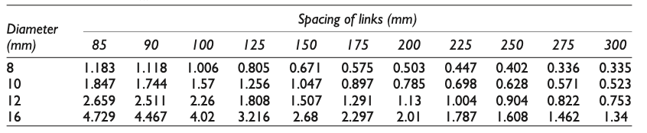

Table 9: Steel Area Provided by Link Spacing for Different Diameters from EC2

Figure 7: Minimum Length and Lapping of Beam Reinforcement over Support

### Beam C1/2

Beam C1/2 carries a distributed load over an area of two trapeziums due to both sides being two-way slabs, which primarily include the load of a classroom and a portion of a corridor. To ensure the worst-case scenario is accounted for, this area is calculated using the classroom load of 3 kN/m², representing a higher loading accountability compared to the corridor.

|  |  |  |  |
| --- | --- | --- | --- |
| CEGE0021 | Project  School Design Project | | Job ref:----- |
| Sheet No/ 1 |
| Section:  Beam C1/2 | |
| Calc By.  Group 3. | Checked by: ---- | Date:29/10/2024 |

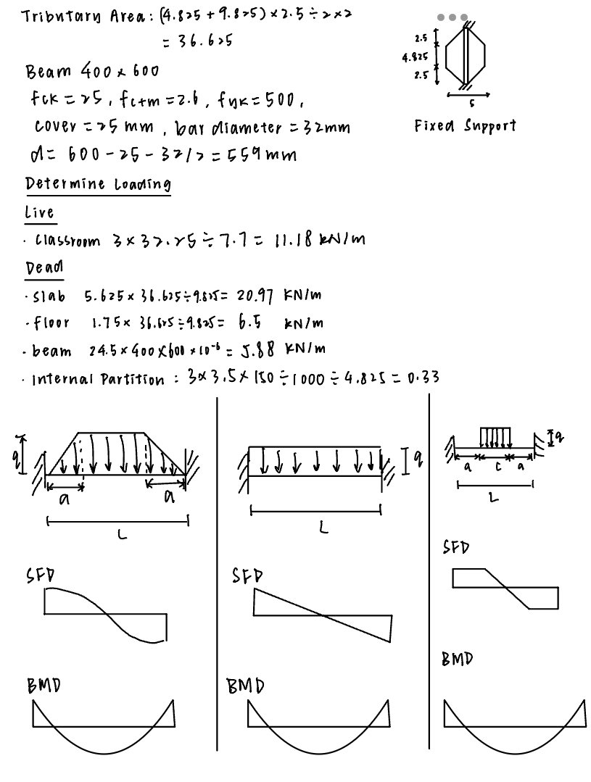

As shown above, the maximum moment is distributed in the mid-span while the maximum shear force is distributed at the supports, therefore, the maximum bending moments and shear forces are calculated at these locations.

|  |  |  |  |
| --- | --- | --- | --- |
| CEGE0021  Grp | Project | | Job ref: |
| School Design Project | | Sheet No/ 2 |
| Section:  Beam C1/2 | |
| Calc By.  Group 3. | Checked by: | Date: 29/10/2024 |

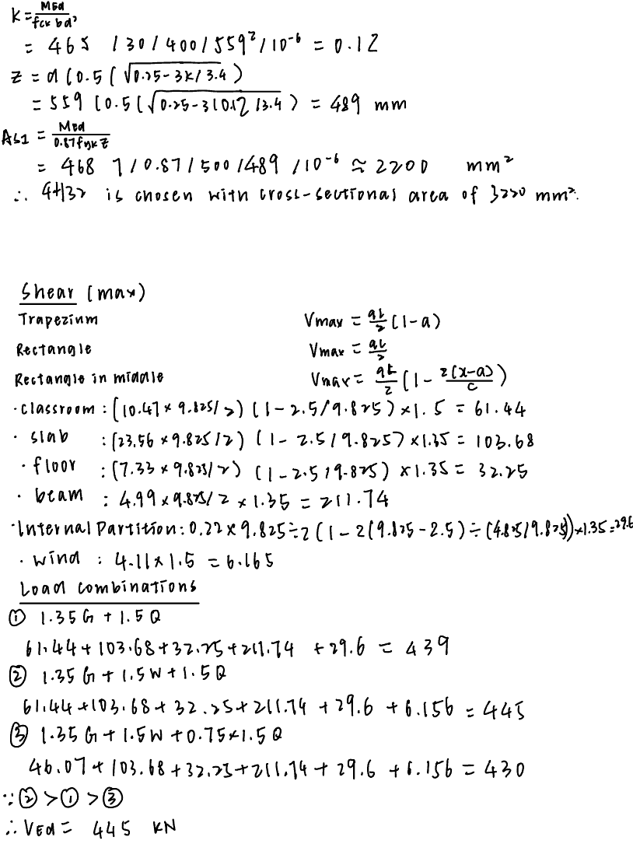

|  |  |  |  |
| --- | --- | --- | --- |
| CEGE0021  Grp | Project | | Job ref: |
| School Design Project | | Sheet No/ 3 |
| Section:  Beam C1/2 | |
| Calc By.  Group 3. | Checked by: | Date: 29/10/2024 |



|  |  |  |  |
| --- | --- | --- | --- |
| CEGE0021  Grp | Project | | Job ref: |
| School Design Project | | Sheet No/ 4 |
| Section:  Beam C1/2 | |
| Calc By.  Group 3. | Checked by: | Date: 29/10/2024 |

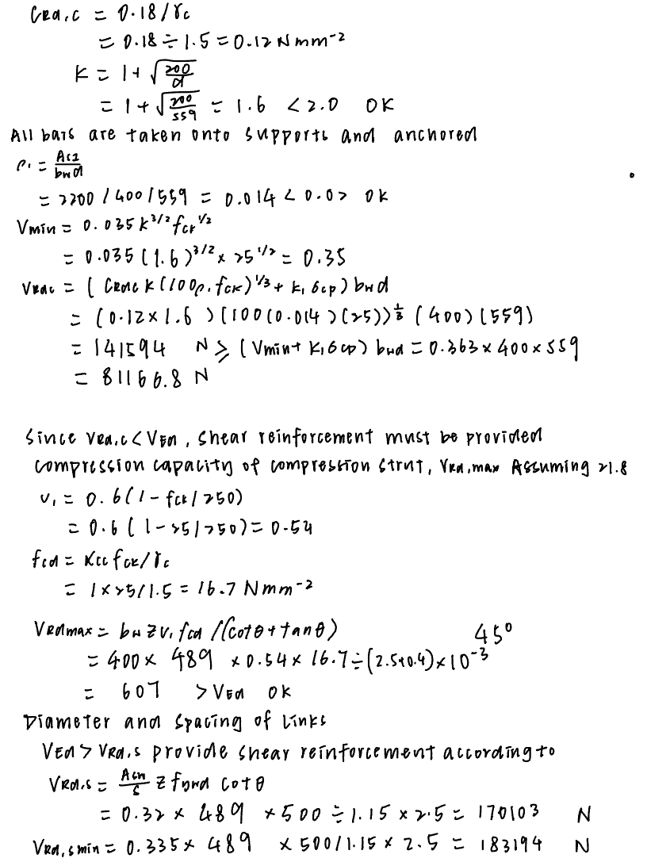

|  |  |  |  |
| --- | --- | --- | --- |
| CEGE0021  Grp | Project | | Job ref: |
| School Design Project | | Sheet No/ 5 |
| Section:  Beam C1/2 | |
| Calc By.  Group 3. | Checked by: | Date: 29/10/2024 |

|  |  |  |  |
| --- | --- | --- | --- |
| CEGE0021  Grp | Project | | Job ref: |
| School Design Project | | Sheet No/ 6 |
| Section:  Beam C1/2 | |
| Calc By.  Group 3. | Checked by: | Date:29/10/2024 |

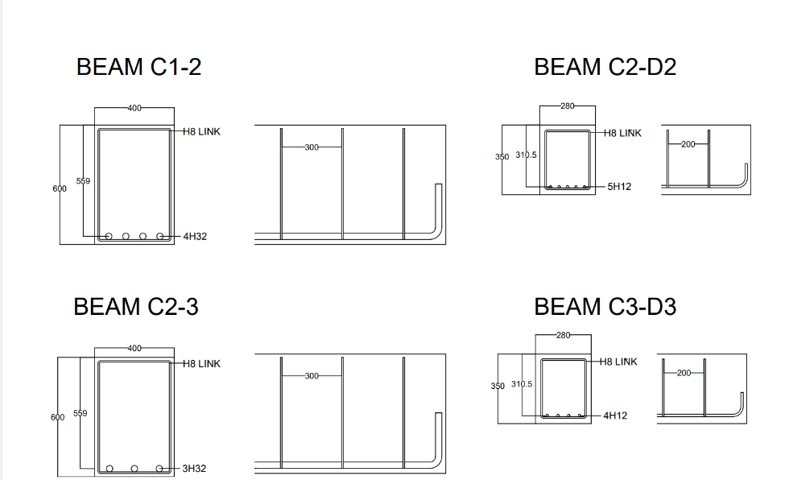

Figure : Beam C1/2 Reinforcement Details

Beam C2/3

Beam C2/3 carries a distributed load over an area of a rectangle and a trapezium as it is between both a one-way and two-way slab, and primarily includes the load of a classroom. The maximum bending moment and shear force are calculated according to the diagrams used for the previous beam.

|  |  |  |  |
| --- | --- | --- | --- |
| CEGE0021  Grp | Project | | Job ref: |
| School Design Project | | Sheet No/ 1 |
| Section:  Beam C2/3 | |
| Calc By.  Group 3. | Checked by: | Date:29/10/2024 |

|  |  |  |  |
| --- | --- | --- | --- |
| CEGE0021  Grp | Project | | Job ref: |
| School Design Project | | Sheet No/ 2 |
| Section:  Beam C2/3 | |
| Calc By.  Group 3. | Checked by: | Date: 29/10/2024 |

|  |  |  |  |
| --- | --- | --- | --- |
| CEGE0021  Grp | Project | | Job ref: |
| School Design Project | | Sheet No/ 3 |
| Section:  Beam C2/3 | |
| Calc By.  Group 3. | Checked by: | Date: 29/10/2024 |

|  |  |  |  |
| --- | --- | --- | --- |
| CEGE0021  Grp | Project | | Job ref: |
| School Design Project | | Sheet No/ 4 |
| Section:  Beam C2/3 | |
| Calc By.  Group 3. | Checked by: | Date: 29/10/2024 |

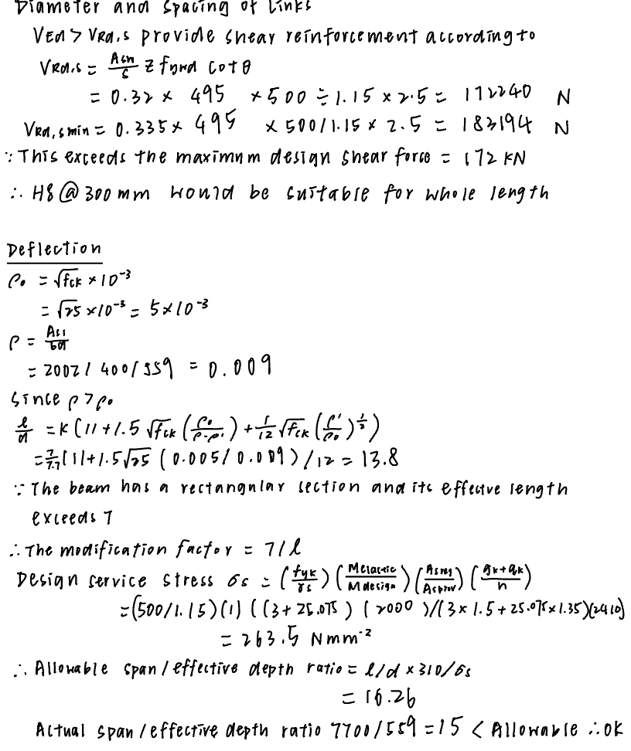

|  |  |  |  |
| --- | --- | --- | --- |
| CEGE0021  Grp | Project | | Job ref: |
| School Design Project | | Sheet No/ 5 |
| Section:  Beam C2/3 | |
| Calc By.  Group 3. | Checked by: | Date: 29/10/2024 |

Figure : Beam C2/3 Reinforcement Details

### Beams C2-D2

Similar to Beam C2/3 and Beam C1-2, the shorter beams were also calculated using the same method. C2-D2 carries a load from a two-way slab and has a triangular tributary area. The area above the beam is not accounted for since it’s a cutout for stairwell and a one-way slab distributed to a vertical beam. The ultimate bending moment and shear forces were calculated based on the Table 15.3 in the Concise EC2, based on the assumption that it is a continuous beam.

|  |  |  |  |
| --- | --- | --- | --- |
| CEGE0021  Grp | Project | | Job ref: |
| School Design Project | | Sheet No/ 1 |
| Section:  Beam C2-D2 | |
| Calc By.  Group 3. | Checked by: | Date: 29/10/2024 |

|  |  |  |  |
| --- | --- | --- | --- |
| CEGE0021  Grp | Project | | Job ref: |
| School Design Project | | Sheet No/ 2 |
| Section:  Beam C2-D2 | |
| Calc By.  Group 3. | Checked by: | Date: 29/10/2024 |

Figure : Beam C2-D2 Reinforcement Detail

Beam C3-D3

Beam C3-D3 carries the load from a tributary area of a rectangle from a one-way slab. Likewise, only half of the beam would withstand the UDL since the left side of the beam is loaded over the vertical Beam

|  |  |  |  |
| --- | --- | --- | --- |
| CEGE0021  Grp | Project | | Job ref: |
| School Design Project | | Sheet No/ 1 |
| Section:  Beam C3-D3 | |
| Calc By.  Group 3. | Checked by: | Date: 29/10/2024 |

|  |  |  |  |
| --- | --- | --- | --- |
| CEGE0021  Grp | Project | | Job ref: |
| School Design Project | | Sheet No/ 2 |
| Section:  Beam C3-D3 | |
| Calc By.  Group 3. | Checked by: | Date:29/10/2024 |

|  |  |  |  |
| --- | --- | --- | --- |
| CEGE0021  Grp | Project | | Job ref: |
| School Design Project | | Sheet No/ 3 |
| Section:  Beam C3-D3 | |
| Calc By.  Group 3. | Checked by: | Date:29/10/2024 |



Figure : Beam C3-D3 Reinforcement Details

# Column design

## Ground floor column **C2** DESIGN CALCULATION

The following column design calculations provide a comprehensive structural assessment for a 50-year design life column under exposure class XC1, ensuring compliance with fire resistance standards of 1-hour (structural class S3, suitable for schools). This column, with a minimum concrete cover requirement of 20 mm and a nominal cover of 30 mm, is evaluated for adequate strength, stability, and reinforcement under various loading scenarios. Material properties include a concrete strength of $f_{ck}$ = 30 MPa

and a steel yield strength of $f_{yk}$ =500 MPa a, with reinforcement specifications of 4 bars of 12 mm diameter and 6 mm links spaced at 300 mm. Load assessments include dead, live, and self-weight contributions from the roof, slabs, and beams, totalling a roof load of 602.11 kN. Bending moments and axial loads are calculated for wind and lateral load effects, resulting in a design moment $M_{Ed}$ ​ of 82.57 kNm, which meets the moment resistance requirement $M_{Rd}$ =134.4kNm, confirming the column’s adequacy.

Figure : Drawing of typical beams to column rebar lapping schedule.

Figure : Drawing of end anchorage of column bars.

|  |  |  |  |
| --- | --- | --- | --- |
| CEGE0021  Grp | Project  School Design Project | | Job ref: |
| Sheet No/ 1 |
| Section: Column | |
| Calc By.  Group 3. | Checked by: | Date: 29/10/2024 |
|  | | | |

|  |  |  |  |
| --- | --- | --- | --- |
| CEGE0021  Grp | Project  School Design Project | | Job ref: |
| Sheet No/ 2 |
| Section: Column | |
| Calc By.  Group 3. | Checked by: | Date: 29/10/2024 |
|  | | | |

|  |  |  |  |
| --- | --- | --- | --- |
| CEGE0021  Grp | Project  School Design Project | | Job ref: |
|  |
| Sheet No/ 3 |
| Section: Column | |
| Calc By.  Group 3. | Checked by: | Date: 29/10/2024 |
|  | | | |

|  |  |  |  |
| --- | --- | --- | --- |
| CEGE0021  Grp | Project  School Design Project | | Job ref: |
| Sheet No/ 3 |
| Section: Column | |
| Calc By.  Group 3. | Checked by: | Date: 29/10/2024 |
|  | | | |

|  |  |  |  |
| --- | --- | --- | --- |
| CEGE0021  Grp | Project  School Design Project | | Job ref: |
| Sheet No/ 4 |
| Section: Column | |
| Calc By.  Group 3. | Checked by: | Date: 29/10/2024 |
|  | | | |

|  |  |  |  |
| --- | --- | --- | --- |
| CEGE0021  Grp | Project  School Design Project | | Job ref: |
| Sheet No/ 5 |
| Section: Column | |
| Calc By.  Group 3. | Checked by: | Date: 29/10/2024 |
|  | | | |

|  |  |  |  |
| --- | --- | --- | --- |
| CEGE0021  Grp | Project  School Design Project | | Job ref: |
| Sheet No/ 6 |
| Section: Column | |
| Calc By.  Group 3. | Checked by: | Date: 29/10/2024 |
|  | | | |

|  |  |  |  |
| --- | --- | --- | --- |
| CEGE0021  Grp | Project  School Design Project | | Job ref: |
| Sheet No/ 7 |
| Section: Column | |
| Calc By.  Group 3. | Checked by: | Date: 29/10/2024 |
|  | | | |

# Base Plate and Connections

## Base Plate Design

## Column to Base Connection Design for lapping of reinforcement

As shown in the drawing below, a general sketch of the lapping and the anchorage for the connection between column and padding foundation.

Figure : Drawing on typical details of starter bars for column to padding foundation.

# Foundation Design

## Foundation Structure and Calculations

The foundation design calculations for base **C2** are conducted in accordance with Eurocode standards, utilizing grade C30/37 concrete to achieve the necessary strength and durability. This calculation outlines the required base area, depth, and reinforcement for a square pad foundation, with each component assessed to ensure compliance with Eurocode specifications. Key checks have been performed to confirm structural adequacy, while additional checks are identified to further verify compliance with safety and performance requirements.

**Relevant Assumptions**

* The foundation is modelled as a square pad with a maximum side length of 3.8m to avoid interference with adjacent columns.
* Trial depth is initially set to 0.65 m and adjusted based on trial-and-error for moment and shear capacity.
* Self-weight of the foundation is added to service loads.
* Assumes direct load transfer to the soil without ground floor influence on foundation and columns.
* Assumes no shear reinforcement; punching shear is checked against Eurocode guidelines.
* Earth pressure distribution is uniform across the base area, and the foundation acts as a rigid body with a fixed column connection.

**Design Loads and Bearing Capacity**

**Characteristic Service Load:**

Total load, including self-weight of the pad: **1327.04 $kN$**  (no factor of safety applied).

**Soil Bearing Capacity:**

Allowable soil bearing maximum capacity: **175 ${kN/m}^{2}$** , as specified.

**Concrete Specifications:**

* Concrete grade C30/37

$f_{ck}=35 MPa$

$f_{yk}=500 MPa$

**Reinforcement details:**

* Bar Diameter: 20 mm
* Cover to Reinforcement: 50 mm

**Material Density:**

* Density of Reinforced Concrete $ρ_{rc}=25 kN/m^{3}$

**Required Base Area Calculation:**

The required base area for the foundation pad is calculated as follows:

$$A_{base,req}=\frac{1327.04 kN}{175 kN/m^{2}}={7.583 m}^{2}$$

A square foundation pad is assumed with a side length of 3.8 m (Maximum allowable width is 3.85m, based on frame distance constraints).

Resulting Base Area,

$$A_{base}=3.8 ×3.8=14.44 m^{2}$$

**Foundation Depth and Self-weight**

**Trial Depth:**

**Assumed Depth:** h = 0.65 m (approximately $h=\frac{L}{10}$).

**Self-weight of the foundation pad:**

$W_{pad}=A_{base}×h×$ $ρ_{rc}=14.44×0.65×25=234.65 kN$

**Design Moment Calculation**

**Ultimate Load on Pad** (including self-weight):

$$N_{ED}=1327.04 kN+\left(1.35 ×234.65\right)=1819.99 kN$$

**Earth Pressure** **Ps:**

$$Ps=\frac{N_{ED}}{A_{base}}=\frac{1819.99}{14.44}=126.04 kN/m^{2}$$

(Since $Ps$ < Soil Bearing Capacity (175 ${kN/m}^{2}$), this value is acceptable.)

**Design Moment**, $M_{ED}$:

${M_{ED}=Ps ×(\frac{L}{2})}^{2}$ = 126.04 $×$ (${\frac{3.8}{2})}^{2}=364.25 kN/m$

**Note:** Moment induced by column is assumed negligible as the column and pad foundation are fixed

**Ultimate Moment Capacity**

**Effective Depth:**

$$d=h-cover-\frac{bar diameter}{2}=650-50-\frac{20}{2}=580 mm=0.58 m$$

$$M_{RD}=6404 kNm> M_{ED}=364.25 kNm (OK)$$

**Main Reinforcement Design**

**Steel ratio calculation K:**

$$K=\frac{M_{ED}}{f_{ck}×b×d^{2}}=\frac{364.25×{10}^{3}}{35×3.8×{0.58}^{2}}=0.0081$$

**Lever arm $z$** :

$$z=d\left(0.5+\sqrt{0.25-\frac{K}{0.9}}\right)=334×\left(0.5+\sqrt{0.25-\frac{0.0081}{0.9}}\right)=0.5747 m$$

**Required steel Area $A_{s1}$** :

$$A_{s1}=\frac{M_{ED}}{f_{yk}×0.87×z}=\frac{364.25×{10}^{6}}{500×0.87×574.27}=2394.43 {mm}^{2}$$

Reinforcement selection: H20 @ 75 mm spacing yielding $A_{s}=4187$ ${mm}^{2}$

**Minimum Steel Area Check**

(OK)

**Punching Shear Verification**

**Shear Stress $v_{Ed}:$**

$$v_{Ed}=\frac{V_{Ed}}{u_{0}×d}=\frac{1033.10}{8.8885×0.58}=0.2004 N/{mm}^{2}$$

Shear capacity $v_{Rd}:$

$${v_{Rd}=C_{Rd,c}×k×\left(100ρf_{ck}\right)}^{\frac{1}{3}}×\frac{2d}{a}$$

With $ρ$ =0.0111, $f_{ck}=35$, and calculated constants:

$v_{Rd}=0.4403$ $N/{mm}^{2}$ (OK, as $v_{Rd}>v_{Ed}$**)**

**Face Shear Verification**

**Shear Force** :

**Maximum Shear Resistance $v_{Rd,max}:$**

$v_{Rd,max}=0.5 ×v×f_{cd}=6.02 N/{mm}^{2}$ (OK, as $v_{Rd,max}>v_{Ed,face})$

**Transverse Shear Verification (same concept as ex 6.48)**

$$V_{Ed,red}=V_{Ed}- ∆V_{Ed}=1092.0 kN$$

Where, $∆V_{Ed}=P_{s}×A=728.0 kN$, where $A=5.776 mm^{2}$, as show how $A$ is found in the sketch, hence design shear stress (see ex 6.54), $v_{Ed}= β×\frac{V_{Ed}}{u_{0}×d}$, and $V_{Ed}=\frac{V_{Ed,red}}{b×d×v}$, while considering $v= β=1.5$, since is at corner, see National Annexes Table N.A. 1 subclause 6.4.3(6), therefore we get $v_{Ed}=0.495$. Since $v_{Ed}<v_{Rd}$, OK!

# Cost Analysis

## Project Cost Assessment for materials

|  |  |  |  |  |  |  |
| --- | --- | --- | --- | --- | --- | --- |
| Category | Component | Quantity/ Details | | Unit Cost/£ | | Total Cost/£ |
| Concrete/m³ | Steel bar/m  (32mm/20mm/12mm/  10mm/8mm/7mm) | Concrete | Steel bar |
| Structural Elements | Beams | 65.172 | 836.4 / N / 594 /  N / 2047.8 / N | 110 | 32mm: 8.33  20mm: 3.52  12mm: 1.13  10mm: 0.63  8mm: 0.62  7mm: 0.61 | 16000 |
| Columns | 20.16 | N / N /499.68 /  N / N /563.04 | 3100 |
| Slabs | 197.16 | N / N / N /  7814.5 / N / N | 26600 |
| Foundation | Foundations | 168.948 | N / 333 / N /  N / N / N | 130 | 23100 |
| Walls | Exterior Walls | 595.35m² | | 50 | | 29800 |
| Interior Walls | 727.3 m² | | 125 | | 90900 |
| Openings | Doors | 25 | | 400 | | 10000 |
| Roofing | Roof | 876.25 | | 120 | | 48200 |
| Interior Walls | Flooring | 876.25 | | 120 | | 105200 |
| Labour | Engineers | 30% of total labour cost | | N | | 70600 |
| Labour | Contractor | 70% of total labour cost | | N | | 164700 |

Table 10:

Table 10: Project Cost Assesment

Where ‘32mm/20mm/12mm/10mm/8mm/7mm’ means the diameter of the steel bars and ‘N’ means no corresponding size or price.

The exterior wall will be finished with Silicone render. According to ‘*The Ultimate Guide to Rendering Costs Per m2 in the UK*,’ the material costs £35 per m², and scaffolding costs £15 per m². For the total area of 595.35 m², the combined cost for materials and scaffolding is around £29,800.

Labour cost assumption: In most projects, labour accounts for 20% to 40% of the total cost, with materials accounting for the rest (Francis Gichuhi, 2013; Aaron Sullivan, 2019). So we take the maximum of 40% to calculate it, while 70% of the labour cost is allocated to contractors and site workers and 30% to engineers and technical staff.

**Project summary**

Table 11:

|  |  |
| --- | --- |
| Category | Total Cost/£ |
| Structural Elements | 45700 |
| Walls | 120700 |
| Openings | 10000 |
| Foundation | 23100 |
| Roofing | 48200 |
| Interior Finishes | 105200 |
| Labour (Engineers) | 70600 |
| Labour (Contractor) | 164700 |
| Overall Project Cost | 588300 |

Table 11: Overall Project Cost

In conclusion, the total projected cost for the construction project is £588,300, covering all primary categories, including structural elements, walls, openings, foundation, roofing, interior finishes, and labour. Structural and material costs account for a significant portion, while labour, calculated at 40% of the total cost, is split between contractors (70%) and engineers (30%). The detailed breakdown provides a clear allocation of resources, ensuring all essential components are addressed within the budget. This cost analysis establishes a robust foundation for the project's financial planning and execution.

# Carbon Footprint Analysis

## Environmental Impact Assessment

During the construction of school buildings, the prediction of carbon footprint is of great significance and can influence the environmental sustainability of the project. It can be concluded from Table 2 of this guideline that the carbon footprint factor of C25/30 concrete is approximately 0.1 kgCO2e/kg, while that of C32/40 concrete is 0.12 kgCO2e/kg.

By using the Institution of Structural Engineers (IStructE) guide, we can calculate the total embodied carbon footprint of the frame.

In Chapter 2 of this guide, we can get a formula

**Material quantity(kg)×carbon factor (kgCO2e/kg) =embodied carbon(kgCO2e)**

Together with the dimensions obtained at the time of design, we can derive the mass of various materials for each part and multiply them with the carbon factor to get the following two tables.

Table 12: Embodied Carbon of Structural Elements

|  |  |  |  |
| --- | --- | --- | --- |
| **Concrete** | **Weight (kg)** | **Carbon Factor (kgCO2e/kg)** | **Embodied Carbon(kgCO2e)** |
| **Beams** | 162930 | 0.10 | 16293 |
| **Columns** | 50400 | 0.10 | 5040 |
| **Slabs** | 492875 | 0.10 | 49287.5 |
| **Foundations** | 422370 | 0.12 | 50684.4 |
| **Total** |  | | 121305 |

Table 13: Embodied Carbon of Reinforcements

|  |  |  |  |
| --- | --- | --- | --- |
| **Reinforcement** | **Weight (kg)** | **Carbon Factor (kgCO2e/kg)** | **Embodied Carbon(kgCO2e)** |
| **32mm** | 5280.5 | 0.76 | 4013.2 |
| **20mm** | 821.2 | 0.76 | 624.1 |
| **12mm** | 970.9 | 0.76 | 135129.3 |
| **10mm** | 4817.9 | 0.76 | 3661.6 |
| **8mm** | 808.0 | 0.76 | 614.1 |
| **7mm** | 170.1 | 0.76 | 129.3 |
| **Total** |  | | 9780.3 |

**Total embodied carbon=9780.3+121305=131085.3** **kgCO2e**

Since the whole building has two floors, the area can be calculated to be 876.25 square meters, so we can divide the embodied carbon by the area to get the estimated carbon footprint. So:

**131085/876.25=149.59 kgCO2e/m2**

Since stages A1 to A3 account for about 50% of the total carbon sequestration, we can calculate the total carbon sequestration during the structure's lifecycle, which is approximately:

**149.59/50%=299.18 kgCO2e/m2**

# Construction Timeline

The construction project is scheduled to span 27 weeks, running from November 1st to May 2nd, 2025, and organized into sequential phases to enable efficient completion and coordinated teamwork. The project begins with Site Preparation and Foundations, estimated to take 4 weeks, focusing on-site investigation and clearing, excavation, and foundation installation. This is followed by the Structural Frame Construction phase over 8 weeks, where ground-floor and first-floor columns and beams are constructed to form the building’s structural framework. Next, the External Facade and Non-Loadbearing Walls phase, lasting 3 weeks, involves building cavity brickwork and installing glazed facades. The Roof Construction and Installation phase follows, scheduled for 2 weeks, covering the installation of the roof structure and finishes to meet load requirements. Once the exterior is complete, the Internal Partitions and Stairs Installation phase (3 weeks) shapes the internal layout, followed by Mechanical, Electrical, and Plumbing (MEP) Works for 3 weeks, ensuring these systems integrate seamlessly with the structure. Finally, Finishing Works over 5 weeks involve installing flooring, wall finishes, and painting, ensuring alignment with design and aesthetic goals. Below is a Gantt chart illustrating the detailed timeline for each phase, displaying how tasks are distributed across the 27-week project duration.

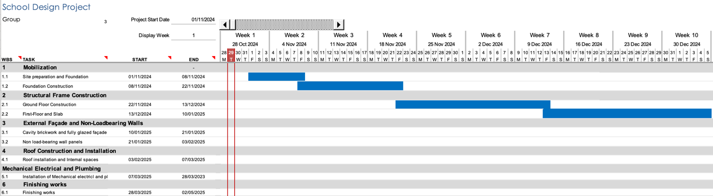

Figure : Construction Timeline Week 1-10

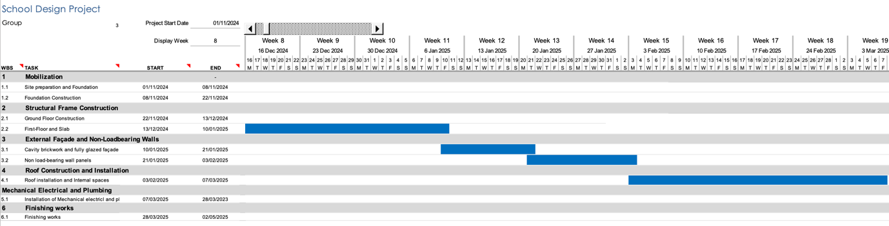

Figure : Construction Timeline 8-19

Figure : Construction Timeline 19-26

Sustainability Cost and Time considerations

# Conclusion

## Summary of Key Findings

# Appendix

Figure : Slab reinforcement

Design of Structural Elements Third Edition. (n.d.).

https://basicengn.wordpress.com/wp-content/uploads/2019/09/arya-chanakya-design-of-structural-elements.pdf

<https://nextdaysteel.co.uk/products/32mm-rebar>

Next Day Steel Ltd. (2023). *T32 Rebar - 32mm High Tensile Reinforcement Bar*. [online] Available at: <https://nextdaysteel.co.uk/products/32mm-rebar> [Accessed 29 Oct. 2024].

IStructE (2020). *How to calculate embodied carbon - The Institution of Structural Engineers*. [online] **Error! Hyperlink reference not valid.**. Available at: <https://www.istructe.org/resources/guidance/how-to-calculate-embodied-carbon/>.

MIDRENDER (Sep 2024), *The Ultimate Guide to Rendering Costs Per m2 in the UK.*

[online] [UK's #1 Professional Rendering Services | MidRender](https://midrender.co.uk/). Available at: [UK Rendering Cost Per m2: Complete Pricing Guide](https://midrender.co.uk/rendering-cost-per-m2-uk/#Silicone_render)

Francis Gichuhi (Apr 2013), *Percentage of Cost Breakdown Between Labour, Materials, and Contractor Profit in Construction*.

[online] [A4Architect. Nairobi. - A4architect](https://www.a4architect.com/). Available at: [PERCENTAGE OF COST BREAKDOWN BETWEEN LABOUR, MATERIALS AND CONTRACTOR PROFIT IN CONSTRUCTION. - A4architect](https://www.a4architect.com/2013/04/percentage-of-cost-breakdown-between-labour-materials-and-contractor-profit-in-construction/#:~:text=In%20most%20projects%2C%20labour%20costs%20approximately%2025%20to,total%20project%20costs%2C%20with%20materials%20taking%20the%20rest.)

Aaron Sullivan (Dec 2019), *What Percentage of Construction Costs Is Labor?*

[online] [Botkeeper | Bookkeeping for Accounting Firms](https://www.botkeeper.com/). Available at: [What Percentage of Construction Costs Is Labor?](https://www.botkeeper.com/blog/construction-labor-cost-percent)

‌

|  |  |  |  |
| --- | --- | --- | --- |
| CEGE0021  Grp | Project  School Design Project | | Job ref: |
| Sheet No/ |
| Section: | |
| Calc By.  Group 3. | Checked by: | Date: |